**Code:**

a=23

c="aaa"

d=23.6

e=True

f=100+3j

g=[1,2,3,4]

h={21:22,32:44}

i=(11,23,"we")

print(type(a))

print(type(c))

print(type(d))

print(type(e))

print(type(f))

print(type(g))

print(type(h))

print(type(i))

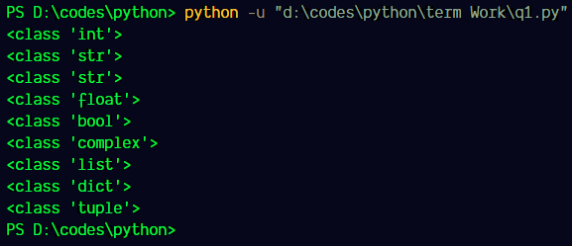

**Code:**

a = 7

b = 2

print ('Sum: ', a + b)

print ('Subtraction: ', a - b)

print ('Multiplication: ', a * b)

print ('Division: ', a / b)

print ('Floor Division: ', a // b)

print ('Modulo: ', a % b)

print ('Power: ', a ** b)

